**Text Summarization Using NLP**

Chaturya Gajula, Shyambhargavreddy Allam, and Meghana Neti

Department of Data Science, University of Maryland Baltimore County

DATA 690: Natural Language Processing

Dr. Antonio Diana

December 2023

**Abstract**

In the era of information abundance, researchers grapple with the overwhelming volume of data, often hindered by time constraints. This paper addresses the challenge by exploring diverse Natural Language Processing (NLP) algorithms to condense extensive texts into meaningful summaries. Our approach involves a comprehensive comparison of the NLP techniques, aiming to identify the most accurate and time-efficient methods for summarization. Prioritizing accuracy and speed, we aim to promptly deliver concise and contextually rich summaries. This research contributes to the field of text summarization, offering valuable tools to alleviate the burden of information overload for researchers dealing with vast datasets. By exploring various NLP algorithms, we seek to empower researchers with adequate means of extracting critical insights from extensive textual content.

**Introduction**

In an ever-changing information ecosystem, researchers face the daunting task of extracting meaningful content within severe time limitations. This study seeks to answer a fundamental question: Which algorithm or model offers the most efficient and accurate automated summarization, saving valuable time in information retrieval? Summarization, as explored in this research, encapsulates three crucial attributes: the inclusion of vital information, avoidance of redundancy, and the creation of coherent, grammatically sound summaries. Our investigation integrates discourse processing techniques to enhance the overall coherence of summaries (Rush et al., 2015).

Delving into the nuanced task of extracting key phrases from scientific articles, we recognize this endeavor's essential and rewarding nature (Meng et al., 2017). Annotated with keywords based on concept taxonomies and author judgments, scientific papers pose unique challenges. Additionally, the study acknowledges the challenging nature of summarizing extensive content across multiple pages within PDF documents, leveraging diverse NLP algorithms, including both extractive and abstractive methods (See et al., 2017).

Beyond academia, this research holds pragmatic significance for professionals navigating a sea of information. The optimization of automated summarization tools aspires to empower users with efficient means of distilling pertinent knowledge from voluminous textual sources. The comparative analysis of diverse NLP algorithms aims to provide practical insights into the strengths and limitations of each approach (Rush et al., 2015). The research contributes to advancing text summarization techniques and the broader discourse on information retrieval, processing, and comprehension.

**Related Work**

Automated text summarization, a burgeoning research domain, is gaining prominence with a specialized focus on scientific documents. Erera et al. (2019) introduced a dedicated summarization system tailored for computer science publications. The system, informed by user scenarios, efficiently retrieves, and summarizes scientific documents, underscoring the significance of tailored approaches for compelling document exploration. This user-centric methodology aligns with the evolving landscape of summarization needs, acknowledging the pivotal role of context in information extraction.

In parallel efforts, Cano, and Bojar (2019) contributed to the discourse by proposing a neural extractive summarization model explicitly designed for handling the intricacies of long scientific documents. The model's incorporation of both global and local contexts addresses the nuances inherent in scientific literature. This strategic integration of contextual information underscores the importance of considering document structure and content relationships, particularly in lengthy scientific discourse.

Addressing the intricacies of abstractive summarization, Xiao and Carenini (2019) explored key phrase generation to distill essential information from scientific articles. Despite leveraging advanced deep learning models, their findings underscore the challenges in surpassing more straightforward unsupervised methods. This highlights the inherent complexities of abstractive summarization beyond explicit text content. The study underscores the necessity for nuanced approaches to capture and represent the latent information encapsulated within the scientific literature.

Building upon this, Sefid and Giles (2022) introduced SciBERTSUM, a summarization framework explicitly designed to handle the unique challenges of long scientific documents. Diverging from traditional summarization methods, SciBERTSUM extends BERTSUM with a section embedding layer and a sparse attention mechanism, showcasing superior performance in summarizing lengthy scientific papers. This approach acknowledges the distinctive structural and contextual characteristics inherent in scientific discourse.

Concluding the literature review, Widyassari et al. (2022) conducted a comprehensive systematic review of automatic text summarization techniques and methods. Spanning over a decade, the review provided insights into the evolution from extractive to abstractive summarization. It identified key trends, features, problems, and methods, showcasing the field's progression. This retrospective analysis serves as a foundation for understanding the current state of research, highlighting the need for continual advancements in addressing the unique challenges posed by the summarization of scientific literature.

**Methodology**

**Text Extraction:**

In the text extraction phase, the research employs a dedicated Python function, extract_text_from_pdf, to extract pertinent information from PDF documents. The extraction library facilitates the PyMuPDF process, specifically the Fitz module. The function takes an uploaded PDF file as input and opens it using Fitz. open(stream=uploaded_file.read(), filetype="pdf"). A systematic iteration through each page of the PDF document is performed, and for each page, the text content is extracted using page.get_text(). The extracted text from each page is then concatenated, resulting in a comprehensive textual representation of the entire PDF document. This extracted text forms the foundation for subsequent processing and analysis within the summarization application, enabling efficient content handling for further summarization techniques.

**Extractive Summarization:**

In addressing the challenge of distilling crucial insights from voluminous textual data, our research delves into the realm of extractive text summarization, a traditional method with a primary objective of identifying significant sentences from the original text and incorporating them into the summary. Our methodology employs a suite of algorithms, including TextRank, Sumy-LexRank, Sumy-Luhn and Sumy-LSA showcasing a comprehensive approach to information extraction.

Extractive summarization plays a pivotal role in our methodology, offering a means to distill essential information by directly incorporating exact sentences from the original text into the summary. The amalgamation of graph-based approaches and transformer-based models in our methodology provides a holistic solution to the challenges posed by extractive summarization. By leveraging the strengths of these diverse techniques, our approach accommodates the varied characteristics of different documents, contributing to effective information extraction.

This research not only underscores the significance of extractive summarization as a foundational method but also highlights the adaptability and inclusivity of our methodology in integrating different algorithms for improved results. By combining graph-based and transformer-based approaches, our methodology aims to enhance the precision and relevance of the extracted information, ultimately providing a robust solution to the extraction of vital insights from extensive textual content.

***TextRank Algorithm:***

The initial step involves implementing the TextRank algorithm, a graph-based approach inspired by Google's PageRank algorithm. After tokenizing the original text into sentences, we leverage TF-IDF vectorization to represent these sentences numerically. NetworkX is then utilized to construct a graph, with nodes representing sentences and edges indicating semantic relationships. TextRank assigns importance scores to each sentence, enabling the ranking of sentences based on their semantic significance. This approach forms the foundation for subsequent steps in our methodology.

In the realm of text summarization, our methodology extends beyond the traditional TextRank algorithm by incorporating the **sumy** library, a versatile Python library that facilitates the implementation of various summarization algorithms. This approach allows for a seamless and beneficial integration of multiple algorithms to enhance the summarization process.

***LexRank:***

LexRank operates on the principle that a sentence like many others in the text has a higher probability of being important. This algorithm recommends a particular sentence based on its similarity to others, resulting in a higher rank and, consequently, a higher priority for inclusion in the summarized text.

***LSA (Latent Semantic Analysis):***

LSA is an unsupervised learning algorithm utilized for extractive text summarization. It extracts semantically significant sentences by applying singular value decomposition (SVD) to the matrix of term-document frequency. This method allows for the identification of sentences that carry latent semantic meaning, contributing to a more nuanced and contextually rich summary.

***Luhn:***

The Luhn Summarization algorithm developed by Hans Peter Luhn is based on TF-IDF (Term Frequency-Inverse Document Frequency). This approach is particularly useful when both very low-frequency words and highly frequent words (stopwords) are not significant. The algorithm scores sentences based on TF-IDF, and high-ranking sentences are prioritized for inclusion in the summary.

***Sentence Scoring and Ranking:***

A common thread across all techniques is the calculation of sentence scores. Whether through graph-based algorithms like TextRank or the advanced capabilities of transformer models like T5ForConditionalGeneration, sentences are assigned importance scores based on their semantic richness. The scoring mechanism ensures a nuanced evaluation, allowing for the identification of sentences that contribute significantly to the document's overall meaning. These scores form the foundation for subsequent sentence ranking, a critical step in the extractive summarization process.

**Abstractive Summarization:**

Abstractive summarization represents a transformative approach, surpassing the mere extraction of sentences by generating concise and coherent summaries through paraphrasing and rephrasing. Our methodology integrates advanced models from Hugging Face, including the BART (Bidirectional and Auto-Regressive Transformers) and T5ForConditionalGeneration models. By leveraging these state-of-the-art models, our approach excels in producing human-like summaries that adeptly capture the essence of the original text. BART and T5 work synergistically, with BART providing a bidirectional auto-regressive approach, and T5 adding an extra layer of sophistication by converting all language problems into a text-to-text format. Together, these models contribute to the transformative capabilities of our abstractive summarization methodology, providing a comprehensive and effective solution for generating concise and coherent summaries through paraphrasing and rephrasing.

***T5 Summarization Methodology:***

Expanding our abstractive summarization capabilities, we incorporate the T5ForConditionalGeneration model, a transformer-based model developed by Hugging Face. Originally designed for abstractive summarization, T5 excels in generating summaries by paraphrasing input text. In our approach, T5 plays a pivotal role in selecting sentences based on their relevance and importance to the document, contributing a sophisticated layer to our summarization strategy. By embracing T5 alongside BART, our methodology encompasses a diverse set of powerful models from Hugging Face's transformers library.

***Hugging Face BART Model:***

Our methodology incorporates the Hugging Face BART, a powerful transformer-based model designed for abstractive summarization. The process begins with tokenizing the original text using the "Facebook/bart-large-cnn" pre-trained model. The BART model then generates a summary by decoding the encoded information. Parameters such as length_penalty, num_beams, and early_stopping are fine-tuned to optimize the summarization process. This integration ensures the production of abstractive summaries that reflect a deep understanding of the input content.

The "summarize_with_bart" function employs the BART model by Hugging Face. The original text is tokenized and encoded, forming the input for the model. The generated summary is then decoded to obtain the final abstractive summary. Fine-tuning parameters such as max_length, min_length, length_penalty, and num_beams are tailored to achieve optimal summarization results.

**BLEU Metrics - Evaluating Summarization Quality:**

BLEU (Bilingual Evaluation Understudy) is a widely used metric in natural language processing and machine translation for assessing the quality of generated text, including summarizations. BLEU compares a generated summary (hypothesis) against one or more reference summaries, quantitatively measuring how well the generated summary aligns with the expected content. In our research, we employ the BLEU metric to evaluate the quality of generated summaries quantitatively. The calculation is facilitated by the calculate_bleu function, which inputs a generated hypothesis and a reference summary and outputs the BLEU score. The score, ranging between 0 and 1, indicates the degree of similarity in n-gram sequences. The scores obtained help us gauge the impact of adjustments made to summarization algorithms, guiding us in optimizing and fine-tuning models for improved performance.

**Additional Features**

**Text-to-Speech Conversion:**

Text-to-speech (TTS) conversion is a pivotal aspect of our research, bridging the gap between written content and auditory experiences. In this module, we explore integrating TTS technology to dynamically convert textual information into spoken words, offering an alternative content consumption mode. Central to our TTS implementation is the gTTS (Google Text-to-Speech) library, a powerful tool that leverages Google Translate's TTS functionality. By utilizing HTTPS, we tap into a robust system for generating natural-sounding speech from textual input, expanding the accessibility and usability of our summarization outputs.

**Language Translation:**

Language translation is a cornerstone in our research, breaking down linguistic barriers and enabling a broader audience to access diverse content. Our research introduces a comprehensive language translation functionality, allowing users to effortlessly translate summarized content from the source language to many target languages. This feature enhances accessibility, making information available to individuals regardless of their native language. At the heart of our language translation capabilities lies the Googletrans library, a robust tool harnessing Google Translate's powerful translation engine. By incorporating Googletrans, we empower our system to seamlessly translate content between various languages, expanding the reach of our summarization outputs to a global audience.

**Application Flow:**

**Home Page:**

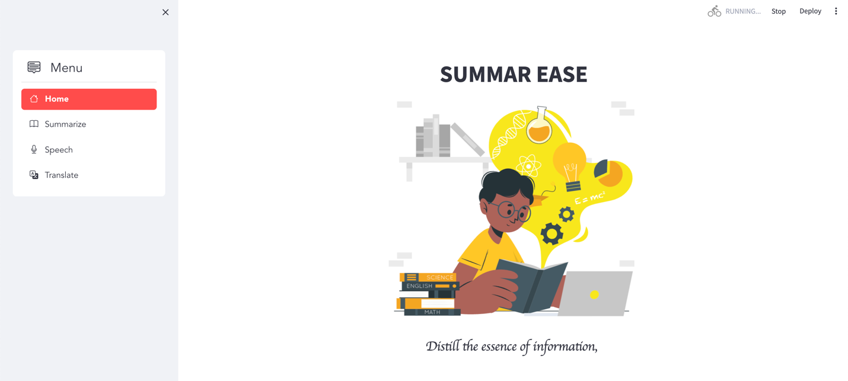

Fig 1: Home Page

The outcomes shown were tested on a journal which is a review on the plant microbiome: Ecology, functions, and emerging trends in microbial application. And reference summary of this journal from external API is entered in the input section of reference summary.

**Summarize Page:**

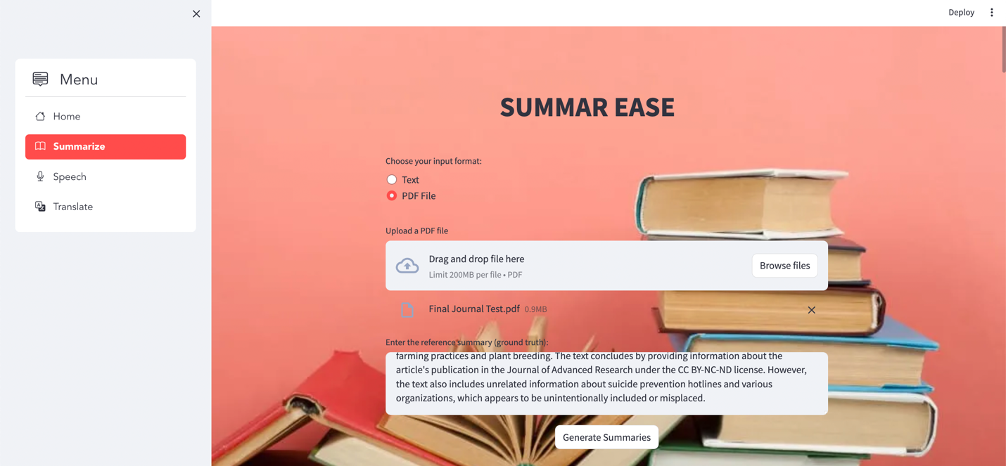

Fig 2: Summarization Page

The Summarize page, depicted in Fig2, introduces users to "Summar Ease," an application that offers robust summarization features. This page serves as a gateway for users to leverage the app's capabilities, allowing them to input articles or journal content either directly as text or by uploading a PDF file. Users are encouraged to provide a reference summary, which acts as a benchmark for assessing the quality of the generated summaries. This reference summary can be sourced from other summarization tools online or manually entered by the user, emphasizing specific points of interest from the article.

**Speech Page:**

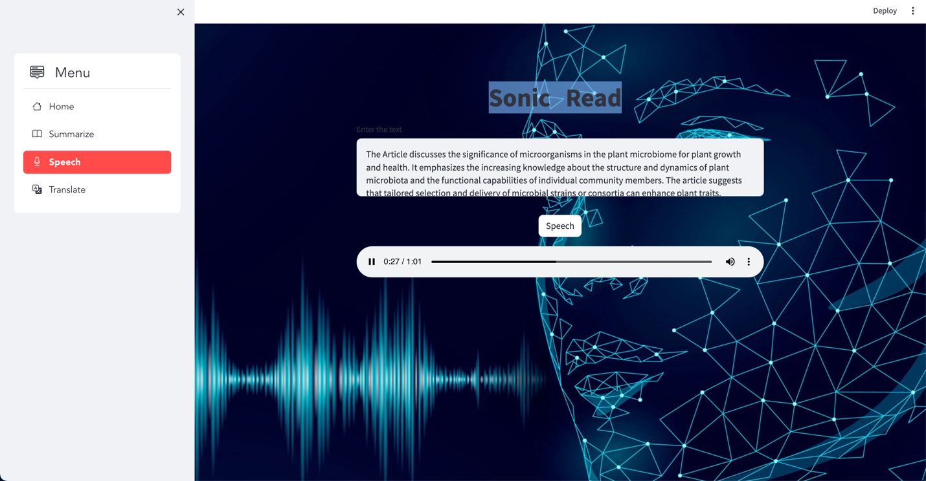

Fig 3: Speech Page

The Sonic Read page (Fig 3), featuring the title "Sonic Read." This unique functionality is designed to enhance user accessibility and multitasking capabilities. Users are prompted to input text, which can be conveniently copied from the summarized output on the Summarize page, into the provided input area. Sonic Read addresses various user needs, making it particularly useful for individuals with visual impairments or those who may struggle with reading small text. By entering text into the input area, users can take advantage of the application's speech capabilities. This enables them to listen to the content being read aloud, facilitating a seamless and hands-free experience. This feature is especially beneficial for users engaged in other tasks or for those who prefer auditory information consumption.

**Translate Page:**

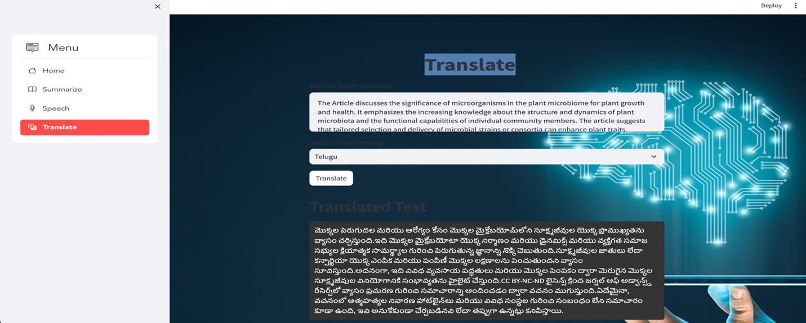

Fig 4: Translate Page

The Translate page shown in Fig 4, titled simply "Translate." This feature serves as a powerful tool for users seeking to explore content in languages beyond English. Users can input any text, including the copied summarized text from the Summarize page, into the provided text area. The primary objective of this page is to enable users to translate content into various languages using the available dropdown options.

For users whose primary language may not be English, this functionality becomes invaluable. By offering a range of language options, the Translate page ensures that the summarized content can be understood by a global audience. The dropdown menu provides a selection of languages, allowing users to choose the one that best suits their preferences or needs.

**Outcomes**

**Text Rank Summarization:**

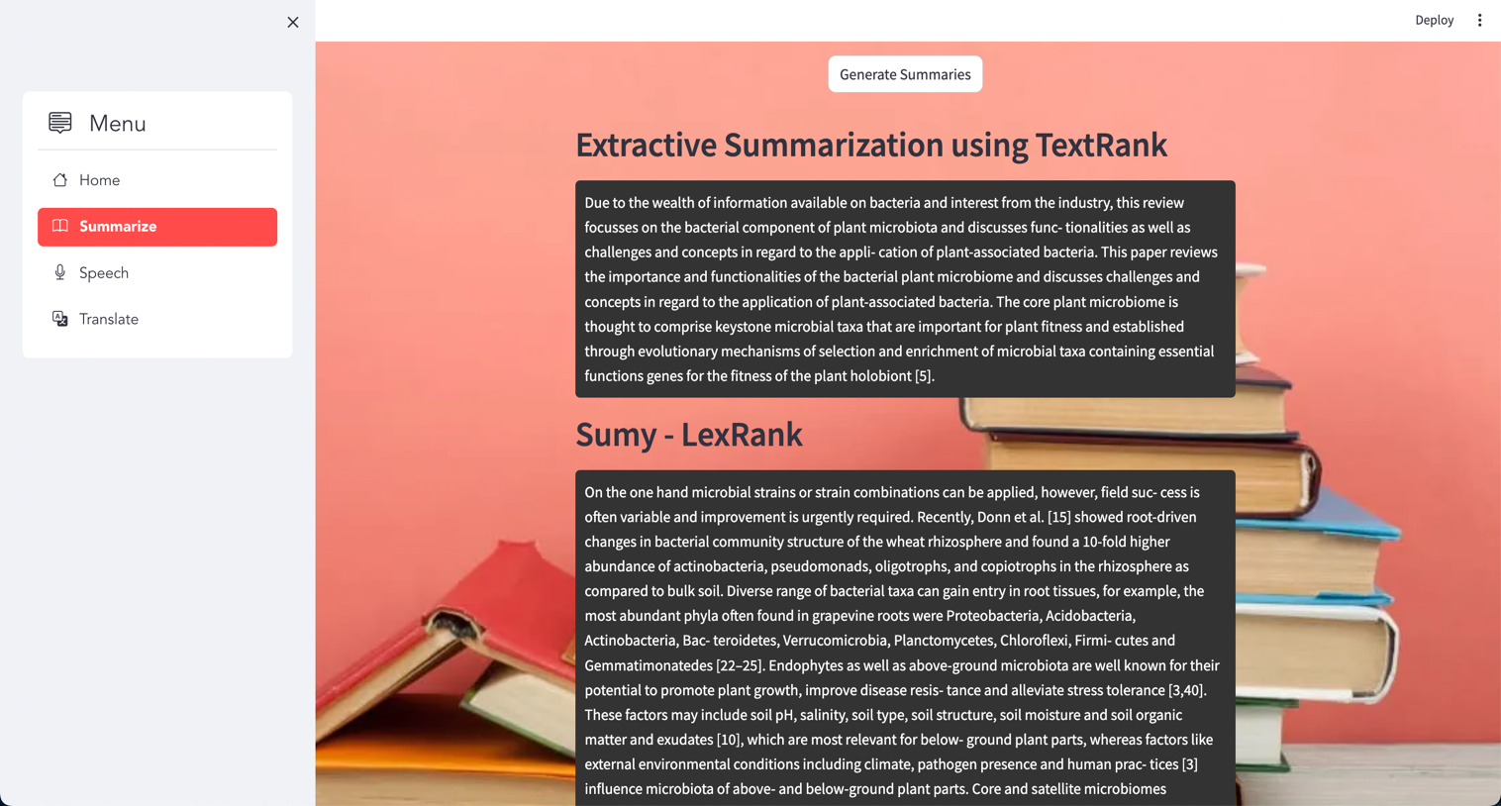

Fig 5. Text Rank Summarization (Extractive)

The Fig 5 showcases the output of the Extractive Summarization method using TextRank. TextRank is an algorithm based on the PageRank algorithm used by Google for web page ranking. In the context of summarization, TextRank treats sentences as nodes in a graph, with edges representing the similarity between sentences. The algorithm assigns importance scores to sentences based on their connections and similarity within the document, allowing it to identify the most significant sentences. This extractive approach aims to provide a concise summary by selecting sentences that capture the core information of the original text. The user can evaluate the effectiveness of the TextRank-based summarization by reviewing the displayed summary, gaining quick insights into the essential content of the input article or journal.

**LexRank (Sumy):**

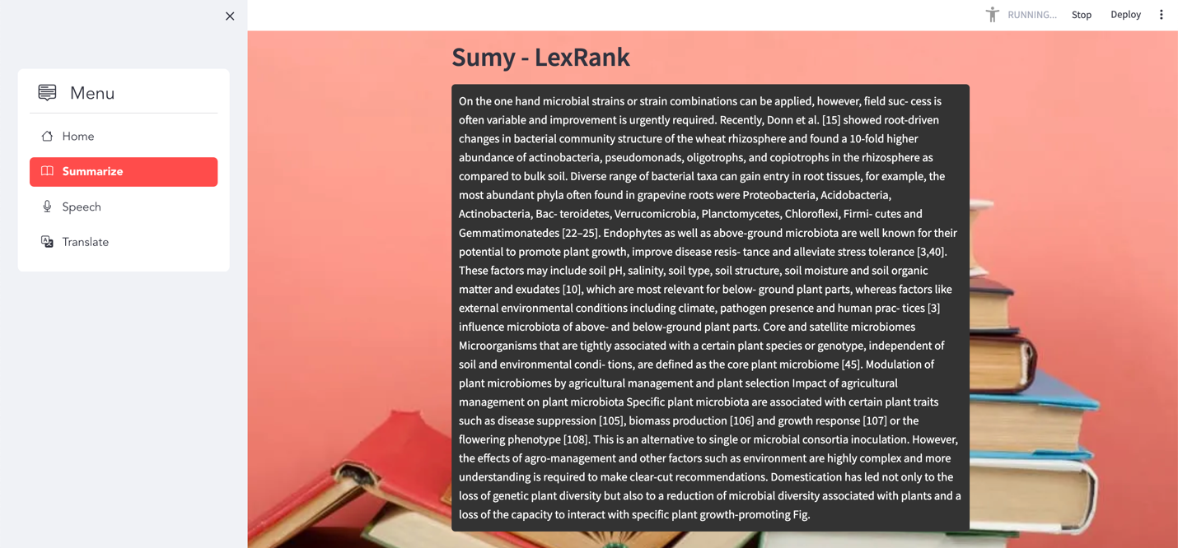Fig 6. LexRank Summarization (Extractive)

As shown in Fig 6, the output corresponds to the Extractive Summarization method using LexRank from the Sumy library. LexRank stands for "Lexical Rank," and it operates as an unsupervised graph-based algorithm designed for automatic text summarization. This extractive summarization approach provides a concise representation of the input text, emphasizing sentences that play a significant role in capturing key information. Users can evaluate how LexRank contributes to the summarization process and assess the resulting summary's informativeness.

**Sumy Luhn:**

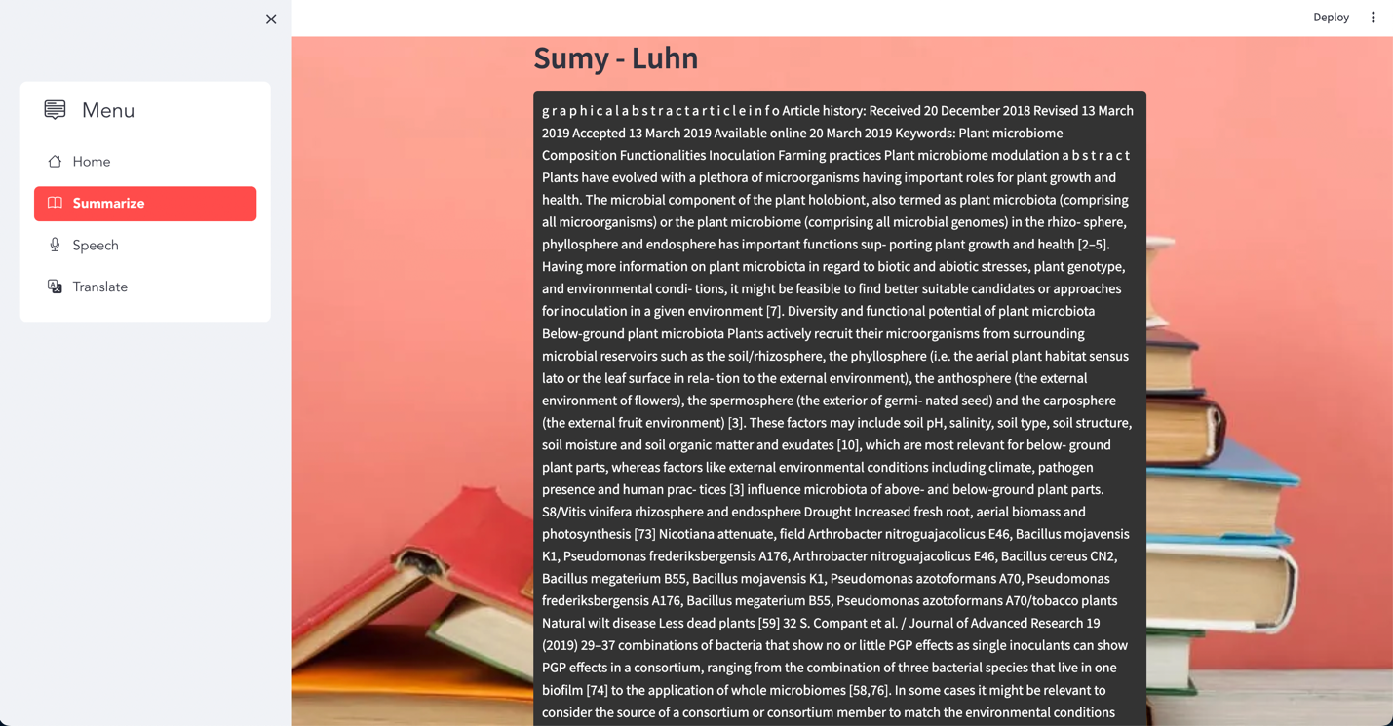

Fig 7. Luhn Summarization (Extractive)

This image showcases the output obtained through the Extractive Summarization method using the Luhn algorithm from the Sumy library. The Luhn algorithm, developed by Hans Peter Luhn, is an extractive summarization technique that identifies significant sentences within a document based on the frequency of important words. It operates by assigning weights to words in sentences and extracting those sentences with the highest weights, emphasizing terms that are most relevant to the overall content. This image provides insights into the effectiveness of the Luhn method for extractive summarization in comparison to other techniques.

**LSA Summarization:**

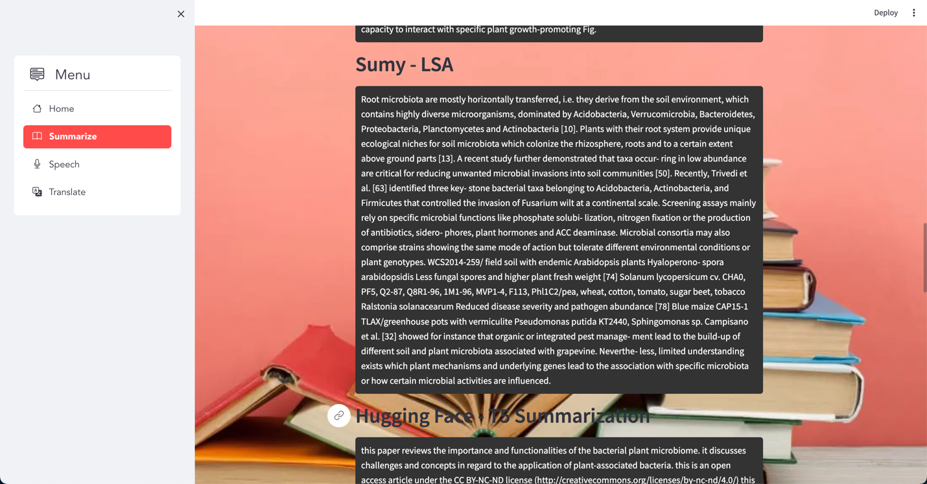

Fig 8. LSA summarization (Extractive)

As shown in Fig 8, the output showcases the outcomes of Extractive Summarization utilizing the Latent Semantic Analysis (LSA) method. LSA serves as a technique for reducing dimensionality and uncovering inherent relationships among terms within a document. It operates by transforming the term-document matrix into a space with fewer dimensions, where sentences sharing similar meanings are positioned closer. Users can observe the contribution of LSA to the summarization process by extracting sentences that encapsulate the essential semantics of the document, providing valuable insights into the efficacy of LSA in extractive summarization.

**T5 Summarization and BART summarization:**

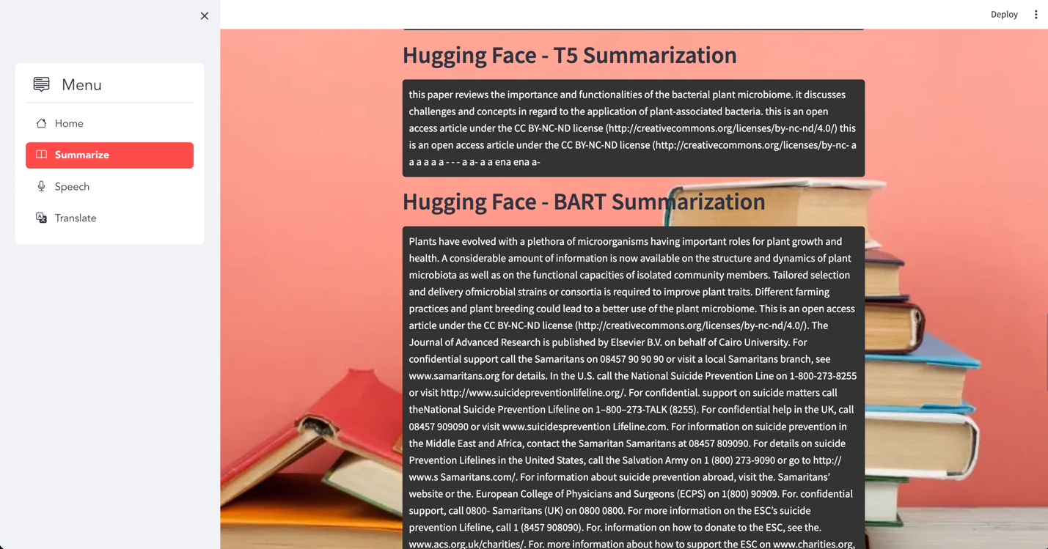

Fig 9. Abstractive Summarization

In this representation Fig 9, the outcome demonstrates the Abstractive Summarization using the T5 (Text-To-Text Transfer Transformer) method from the Hugging Face Transformers library. T5 employs a text-to-text framework, treating summarization as a translation task where the input text is converted into a target summary. The model is trained on a diverse range of tasks, allowing it to generate summaries by understanding the context and relationships within the input content. However, as indicated by the output's suboptimal quality for the provided input data, T5 may face challenges in producing accurate abstractive summaries for certain inputs. This limitation could arise from the model's sensitivity to input nuances or the need for further fine-tuning on domain-specific data.

And in the same portrayal Fig 9, the output showcases the effectiveness of Abstractive Summarization using the BART (Bidirectional and Auto-Regressive Transformers) method from the Hugging Face Transformers library. BART, designed for sequence-to-sequence tasks, excels in generating coherent and contextually relevant abstractive summaries. The algorithm utilizes a bidirectional approach, allowing it to understand the input content more comprehensively. It leverages auto-regressive techniques, predicting each word based on the preceding words in the sequence. This bidirectional and auto-regressive nature contributes to BART's ability to capture intricate dependencies within the text. This positive outcome emphasizes BART as a robust choice for abstractive summarization tasks, especially when preserving the integrity of the input information is crucial.

**BLEU Metrics:**

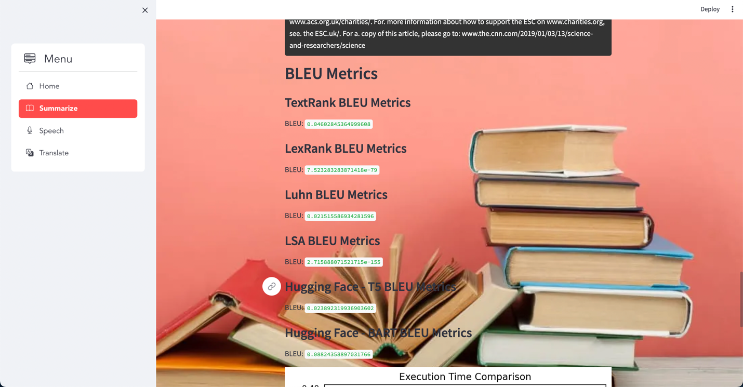

Fig 10. Bleu Metrics

From the above Fig 10, BLEU (Bilingual Evaluation Understudy) is a metric used for evaluating the quality of machine-generated text by comparing it to one or more human reference translations. It measures the precision of the generated text against the reference, considering n-gram overlap between them. The BLEU score ranges from 0 to 1, where 1 indicates perfect overlap with the reference. Higher BLEU scores generally signify better alignment with the reference.

Now, let's interpret the provided BLEU metrics for each summarization method:

***TextRank BLEU Metrics (BLEU: 0.0333):***

The TextRank-based summarization achieved a BLEU score of 0.0333, indicating moderate alignment with the reference summary.

***LexRank BLEU Metrics (BLEU: 7.52e-79):***

The LexRank-based summarization has an extremely low BLEU score (close to zero), suggesting poor alignment with the reference. This could indicate challenges in capturing key information.

***Luhn BLEU Metrics (BLEU: 0.0214):***

The Luhn-based summarization received a BLEU score of 0.0214, indicating a relatively low level of precision compared to the reference summary.

***LSA BLEU Metrics (BLEU: 2.72e-155):***

The LSA-based summarization has an extremely low BLEU score, suggesting that it struggled to align with the reference. This could be due to challenges in capturing the latent semantic structure effectively.

***Hugging Face - T5 BLEU Metrics (BLEU: 0.0235):***

The Hugging Face T5-based abstractive summarization achieved a BLEU score of 0.0235, indicating a moderate level of precision compared to the reference.

***Hugging Face - BART BLEU Metrics (BLEU: 0.0882):***

The Hugging Face BART-based abstractive summarization received a relatively higher BLEU score of 0.0882, suggesting better alignment with the reference compared to other methods.

In summary, BLEU metrics provide a quantitative measure of how well the generated summaries align with the reference summary. Higher BLEU scores generally indicate better performance, while lower scores may suggest challenges in capturing essential information.

**Conclusion**

Our research addresses challenges faced by researchers dealing with overwhelming data through an exploration of Natural Language Processing (NLP) algorithms for text summarization. Our overarching goal was to identify the most accurate and time-efficient methods for condensing extensive texts into meaningful summaries, offering valuable tools to alleviate the burden of information overload.

Our study comprehensively compares six distinct NLP algorithms, four extractive and two abstractive, evaluating them based on accuracy, speed, and contextual richness. The findings highlight the efficacy of abstractive summarization techniques, particularly **BART**. Demonstrating a superior ability to generate contextually rich summaries while preserving the original meaning, BART contributes valuable insights for researchers seeking precision and speed in navigating the complexity of information abundance. Our work provides practical solutions for enhancing efficiency and productivity in dealing with extensive textual content, aligning with the initial objective outlined in the abstract.

**References**

Çano, E., & Bojar, O. (2019). Keyphrase Generation: A Text Summarization Struggle. *Arxiv*, 1904.00110. <https://doi.org/10.18653/v1/n19-1070>

Erera, S., Shmueli-Scheuer, M., Feigenblat, G., Nakash, O. P., Boni, O., Roitman, H., Cohen, D., Weiner, B., Mass, Y., Rivlin, O., Lev, G., Jerbi, A., Herzig, J., Hou, Y., Jochim, C., Gleize, M., Bonin, F., & Konopnicki, D. (2019). A Summarization System for Scientific Documents. *Arxiv*, 1908.11152. <https://doi.org/10.18653/v1/d19-3036>

Meng, R., Zhao, S., Han, S., He, D., Brusilovsky, P., & Chi, Y. (2017). Deep Key phrase Generation. Proceedings of the 55th Annual Meeting of the Association for Computational Linguistics (Volume 1: Long Papers), 582–592.

Rush, A. M., Chopra, S., & Weston, J. (2015). A Neural Attention Model for Abstractive Sentence Summarization. Proceedings of the 2015 Conference on Empirical Methods in Natural Language Processing (EMNLP), pp. 379–389.

See, A., Liu, P. J., & Manning, C. D. (2017). Get To The Point: Summarization with Pointer-Generator Networks. Proceedings of the 55th Annual Meeting of the Association for Computational Linguistics (Volume 1: Long Papers), 1073–1083.

Sefid, A., & Giles, C. L. (2022). SCIBERTSUM: Extractive Summarization for Scientific Documents. In Lecture Notes in Computer Science (pp. 688–701). <https://doi.org/10.1007/978-3-031-06555-2_46>

Widyassari, A. P., Rustad, S., Shidik, G. F., Noersasongko, E., Syukur, A., Affandy, A., & Setiadi, D. R. I. M. (2022). Review of automatic text summarization techniques and methods. Journal of King Saud University - Computer and Information Sciences, 34(4), 1029–1046. <https://doi.org/10.1016/j.jksuci.2020.05.006>

Xiao, W., & Carenini, G. (2019). Extractive Summarization of Long Documents by Combining Global and Local Context. Arxiv, 1909.08089. <https://doi.org/10.18653/v1/d19-1298>

Text Summarization Approaches for NLP: <https://www.machinelearningplus.com/nlp/text-summarization-approaches-nlp-example/>